COURSE CCPS 510
DATABASE SYSTEMS (DBMS) I
ASSIGMENT-I (Version 2)

INSTRUCTOR: | Ersan Cam
INSTRUCTOR E-MAIL: | ersan.cam@torontomu.ca

Please place all your answers and screen shots of your results into this document. Once you finish working on this file, please email me.

This Assignment has different parts each represent different Labs (Ideal time to solve these are in dedicated Lab times of the course)

General Instruction !!!
Please note that for Section B and C, when possible, place your commands under each question tasks as editable form so I can copy past and test. And also under each question please place Execution results screen shot (Snipping Tool)

Lab Section A:
Task 1

Use the following business rules to create a Crow’s Foot ERD. Write all appropriate connectivity and cardinalities in the ERD.
    - A department employs many employees, but each employee is employed by one department.
    - Some employees, known as “rovers,” are not assigned to any department.
    - A division operates many departments, but each department is operated by one division.
    - An employee may be assigned many projects, and a project may have many employees assigned to it.
    - A project must have at least one employee assigned to it.
    - One of the employees manages each department, and each department is managed by only one employee.
    - One of the employees runs each division, and each division is run by only one employee.

Task 2)
Below questions is based on the ERD in Figure 2.
FIGURE 2 - The ERD of
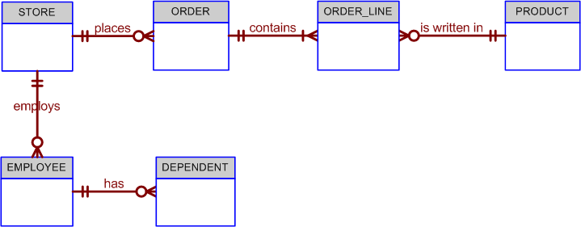

2-a)
Fill Cardinalities. I have left 2 of them on the diagram for you as hint. You can fill rest of 8
The Cardinalities
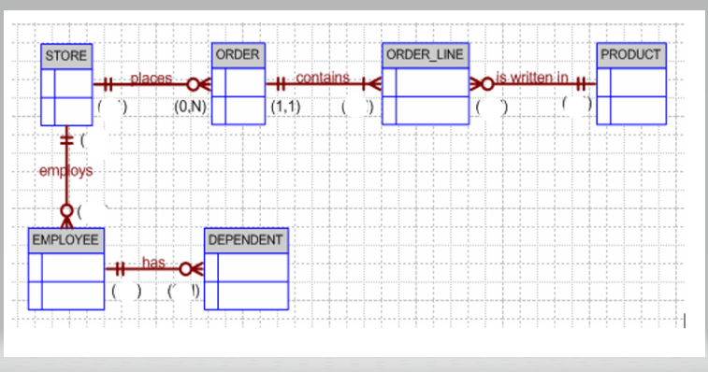

P.S: You can print and write on the paper and take picture and paste here or take this above picture as screen shot and edit on it or use draw.io free cloud tool to complete ERD diagrams.

2-b ) Write at least 6 Business Rules by analyzing ERD diagram above

Normalization

3. Use the dependency diagram shown in Figure 3.1 to work the following problems.

Figure P3.1 Initial Dependency Diagram for Problem 3

a. Break up the dependency diagram in Figure 3.1 to create two new dependency diagrams, one in 3NF and one in 2NF.

b. Modify the dependency diagrams you created in Problem 3 to produce a collection of dependency diagrams that are all in 3NF.

First cut (Draft) version of diagram is given to you in step a as hint… Now enhance your design/dependency chart in step b before Final solution

c. Final Solution

Apply final solution…. Below is partially given you as hint

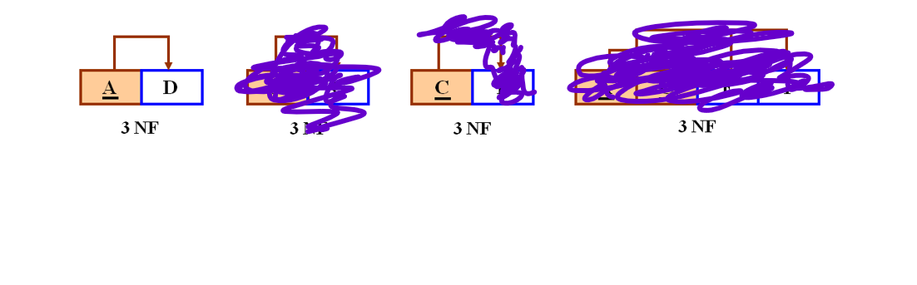

This following section (Lab B) is for Physical Database Design practices to build database tables and add constraints to apply business rules by using DDL (Data Definition Language ) of SQL.

Lab Section B: DDL (Data Definition Commands) to build physical database
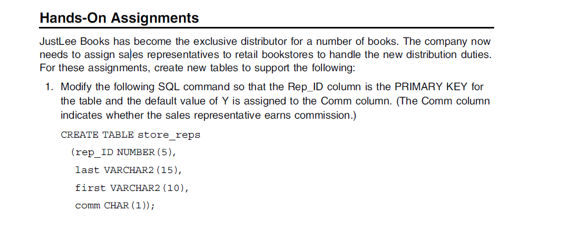
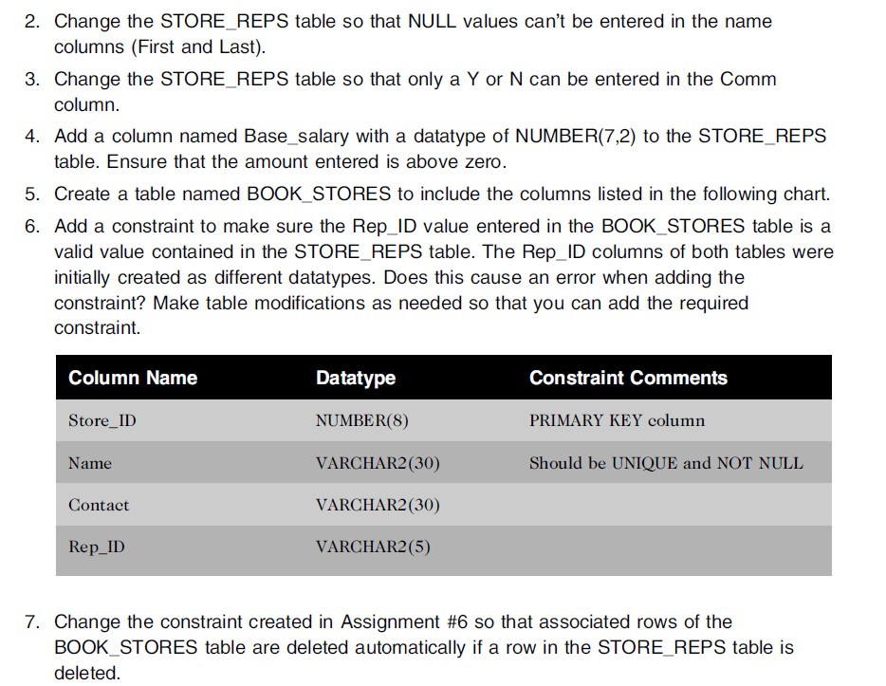
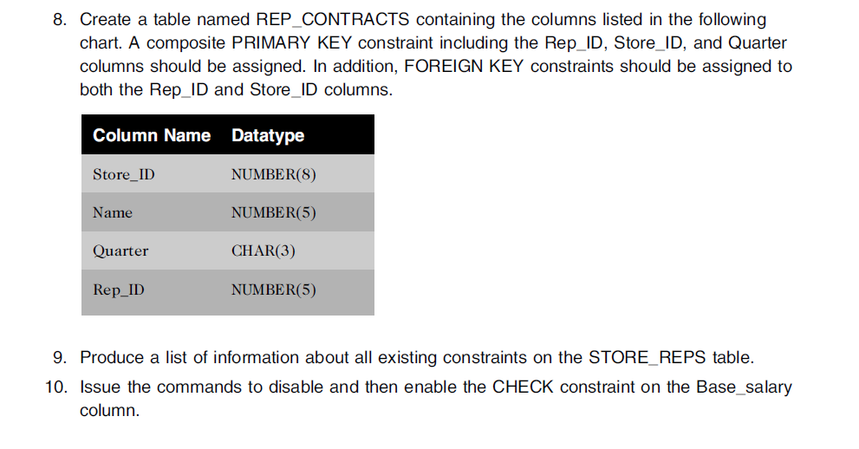

11.
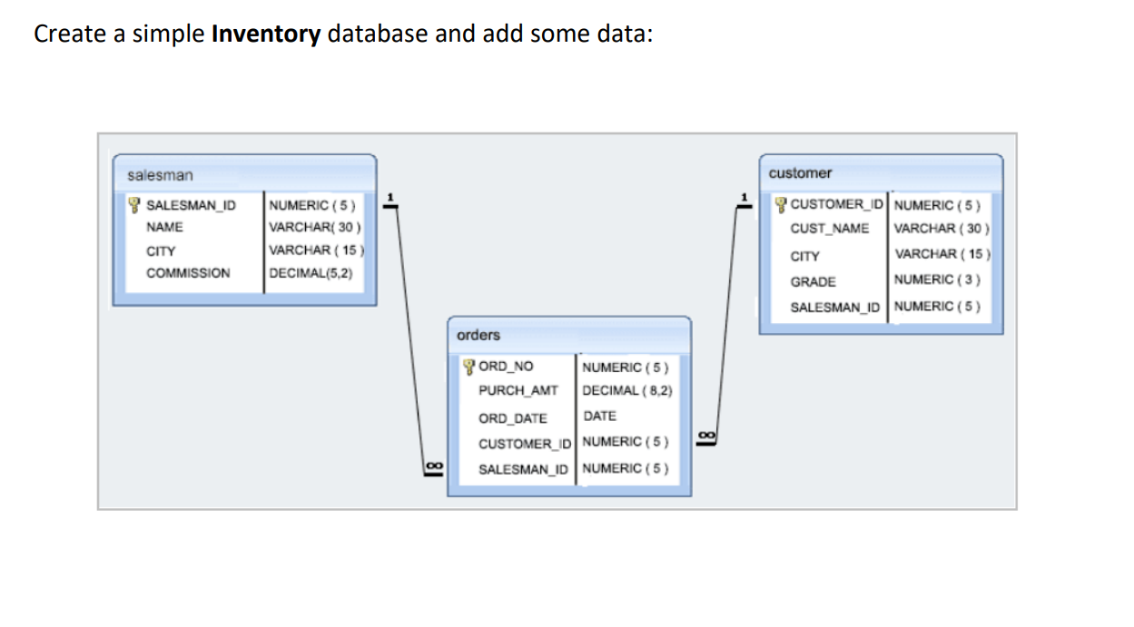
Please create these above 3 tables along with their Primary Key and Foreign key constraints. Make sure you use NUMBER instead of NUMERIC or DECIMAL
Enter some sample data (2 records per each table) by using INSERT statement

This following section (Lab C) is for practice SELECT command to query data.

Lab Section C) SELECT queries

Develop SQL code for below questions.

1- (Please Use Dream Home Database sample Data set)

- Find the number of staff working in each branch and the sum(Total) of their salaries

- For each Branch office , list the staff numbers and names of staff who manage properties and the properties that they manage
Hint: Join Staff and PropertyForRent

- List all properties and any branch offices that are in the same city
Hint: outer join between Branch and PropertyForRent

- Increase all assistant staff salary by %10 (UPDATE)

- For staff name called Ann Beech , write an update command to promote her as Manager and increase her salary to 14000 and also move her to same branch as John White (SL21)

2- Use HumanResources Database for below questions

- Display department name, manager name, and city.

- Display country name, city, and department name.

- Display employee name if the employee joined before his manager.

d.
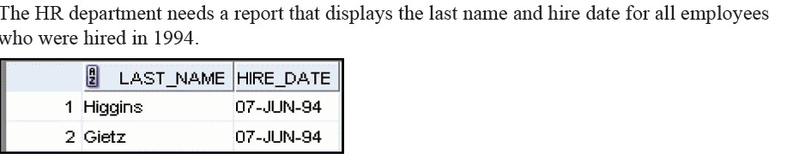
Hint : Use Like with % or TO_CHAR(Hire_Date,’YYYY’) = ‘1994’

e.
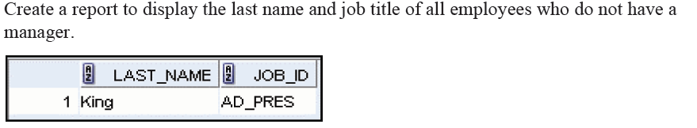

Rubric for Lab Section A, B and C
